1. Search topic like “hotels with pools in sacramento” and click view all hotels

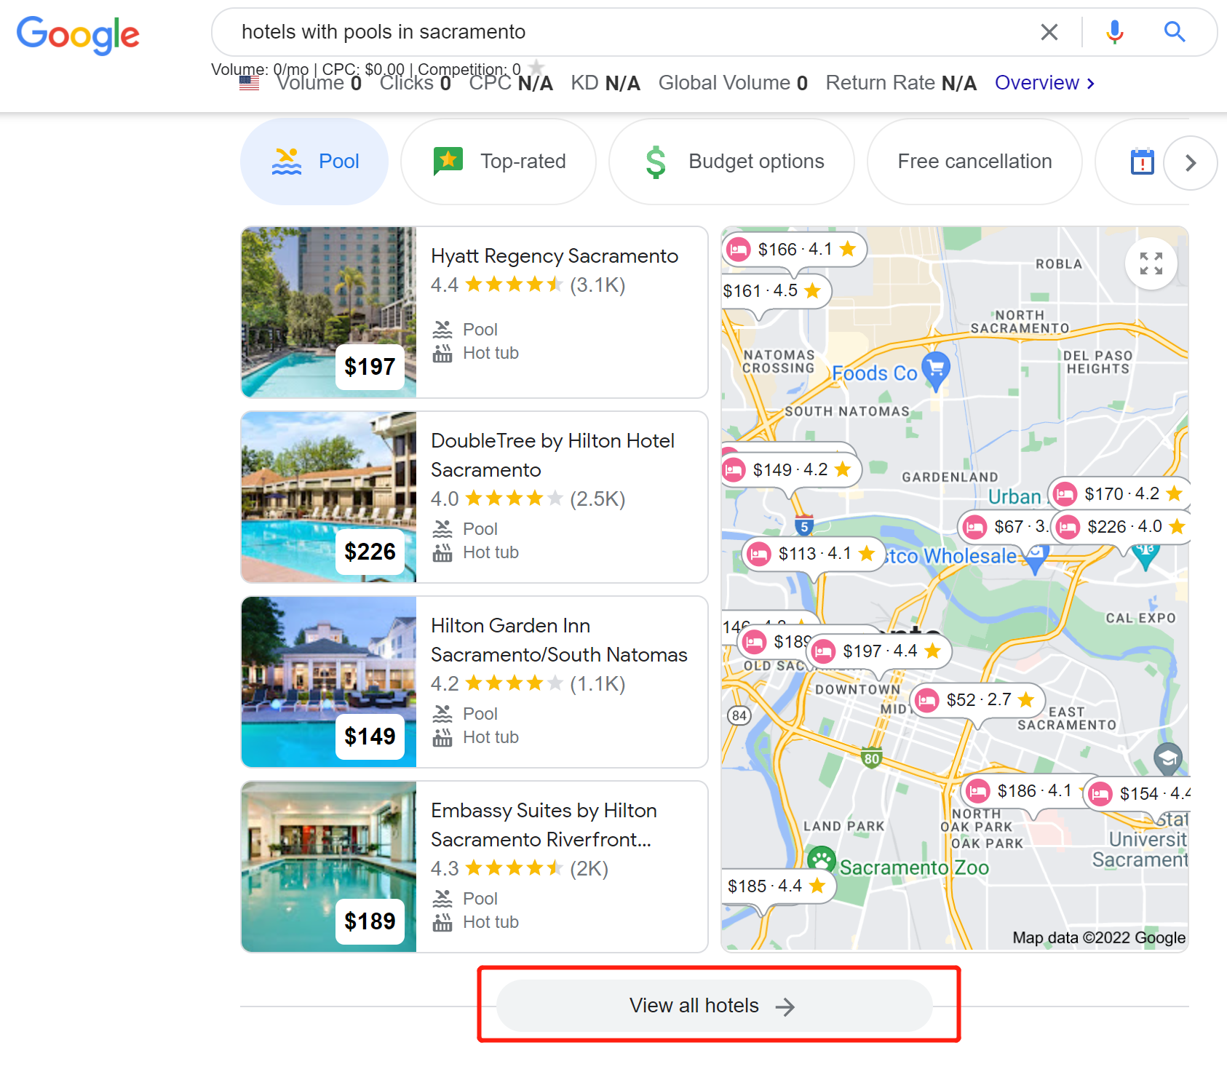

1. Filter ones with 4+ ratings if we have plenty of records (for example 50+ records)

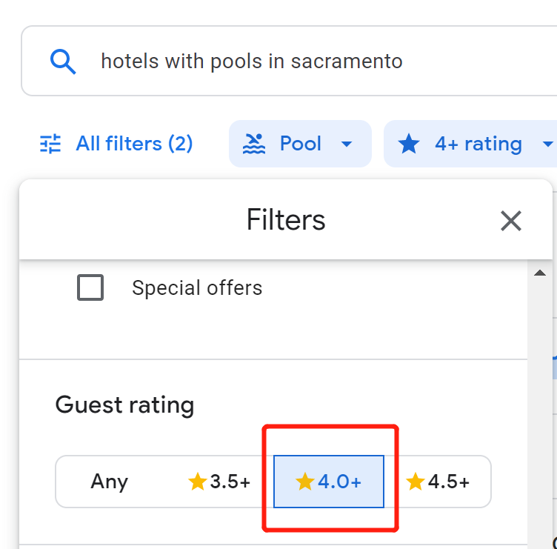

1. Click to see more details on the hotel. For example:

https://www.google.com/travel/hotels/Sacramento%2C%20CA/entity/ChcIjrbbxYyWpe9KGgsvZy8xdHpncGdrZxAB?q=hotels%20with%20pools%20in%20sacramento&g2lb=2502548%2C2503771%2C2503781%2C4258168%2C4270442%2C4284970%2C4291517%2C4306835%2C4515404%2C4597339%2C4703207%2C4718358%2C4722900%2C4723331%2C4741665%2C4757164%2C4758493%2C4762561%2C4786958%2C4790928%2C4794648%2C4814050%2C4816090%2C4816091%2C4819463%2C4819466&hl=en-US&gl=us&ssta=1&ts=CAESCgoCCAMKAggDEAAaMgoUEhA6DlNhY3JhbWVudG8sIENBGgASGhIUCgcI5g8QCBgIEgcI5g8QCBgJGAEyAhAAKhAKCgoBBigBOgNVU0QaACgI&rp=ogEOU2FjcmFtZW50bywgQ0E4AUAASAI&ap=&ictx=1&sa=X&utm_campaign=sharing&utm_medium=link&utm_source=htls&ved=0CAAQ5JsGahcKEwiot8Hbv6z5AhUAAAAAHQAAAAAQAw

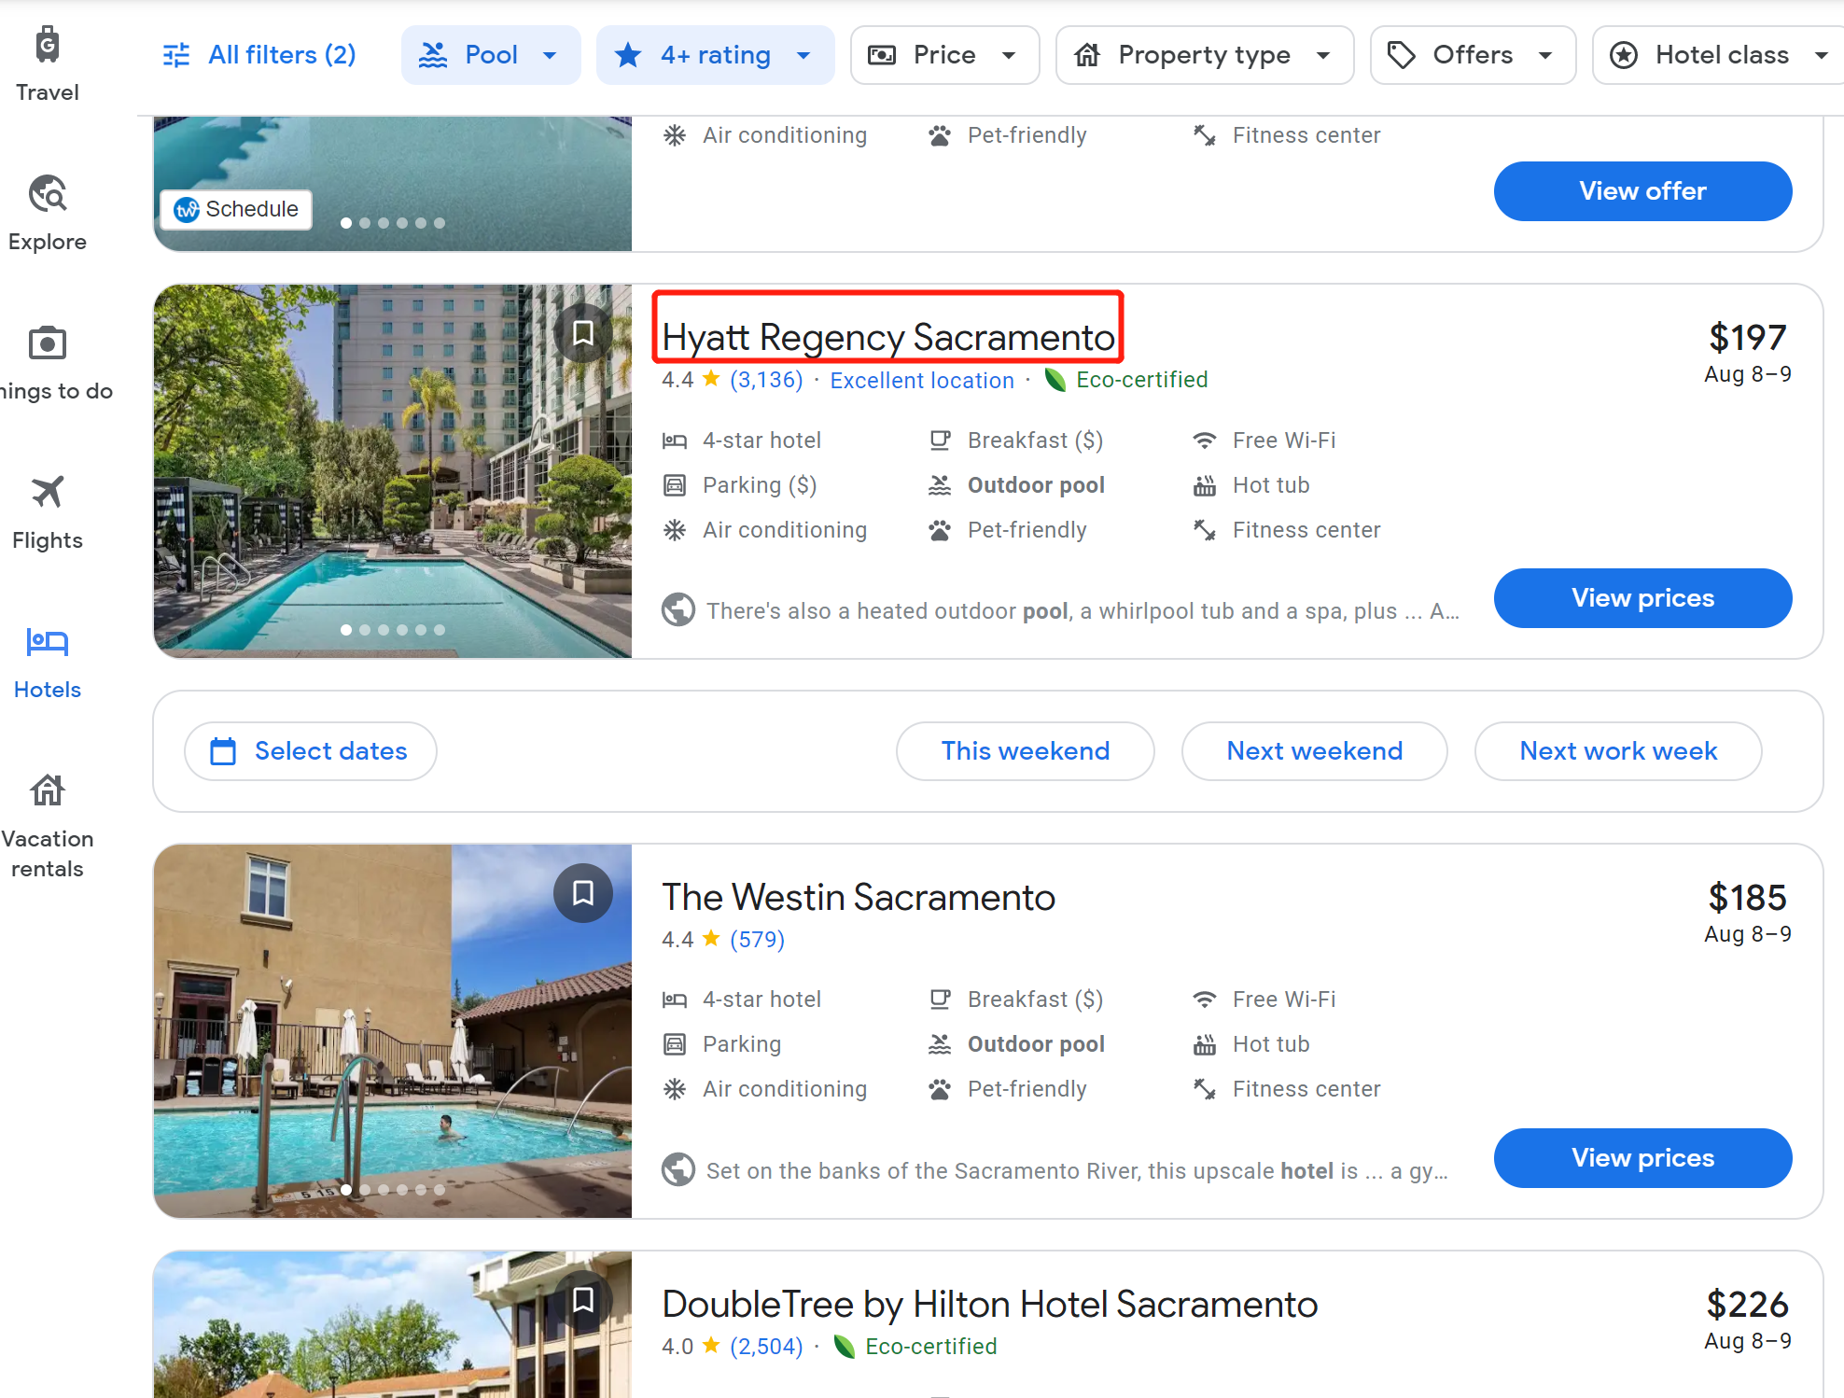

1. Scrape data we need from the hotel detail page

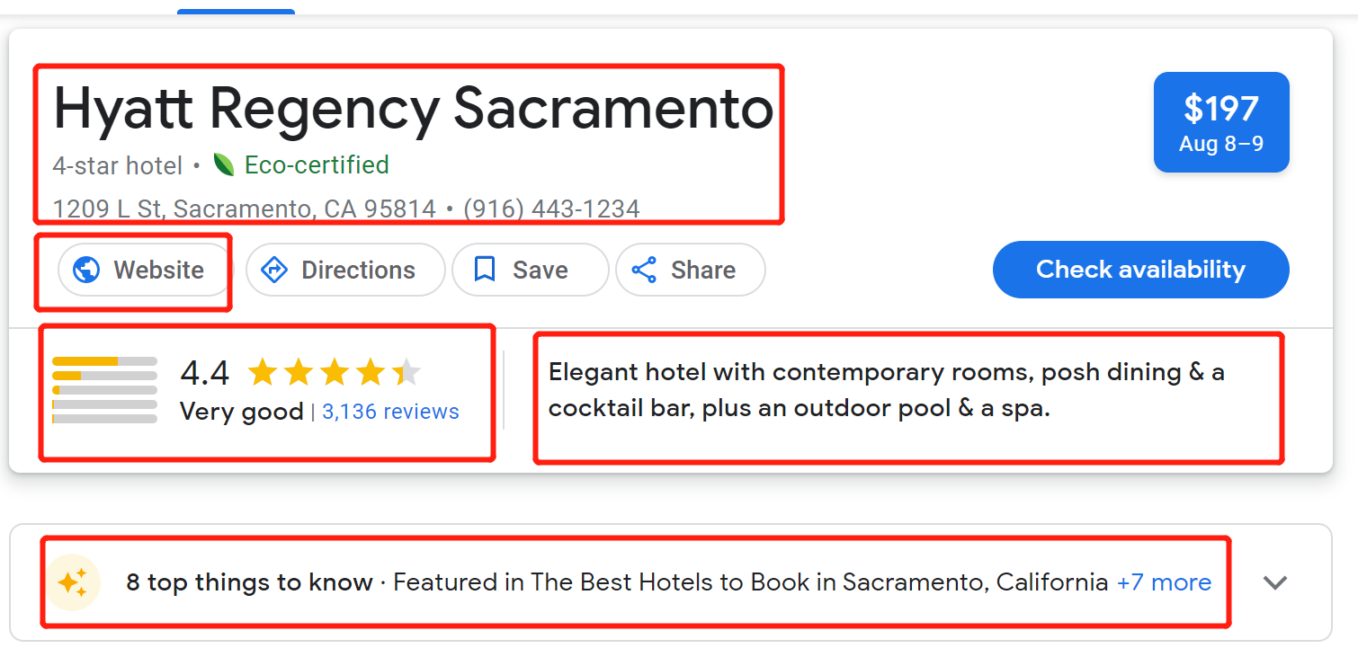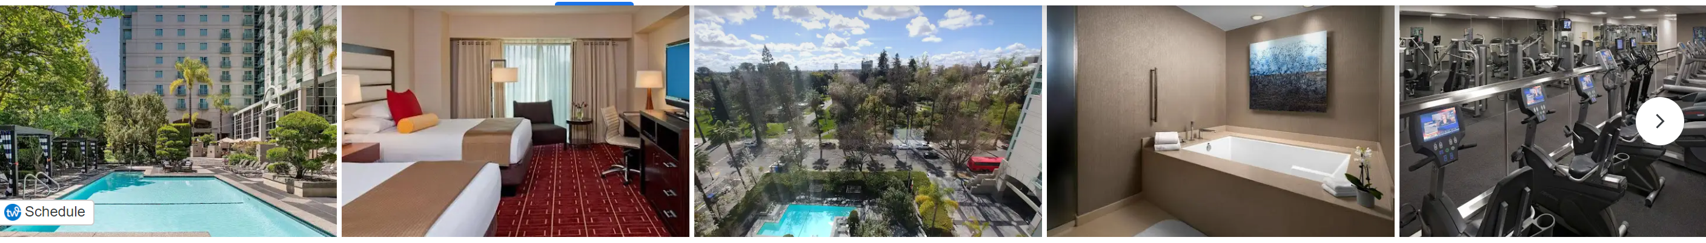

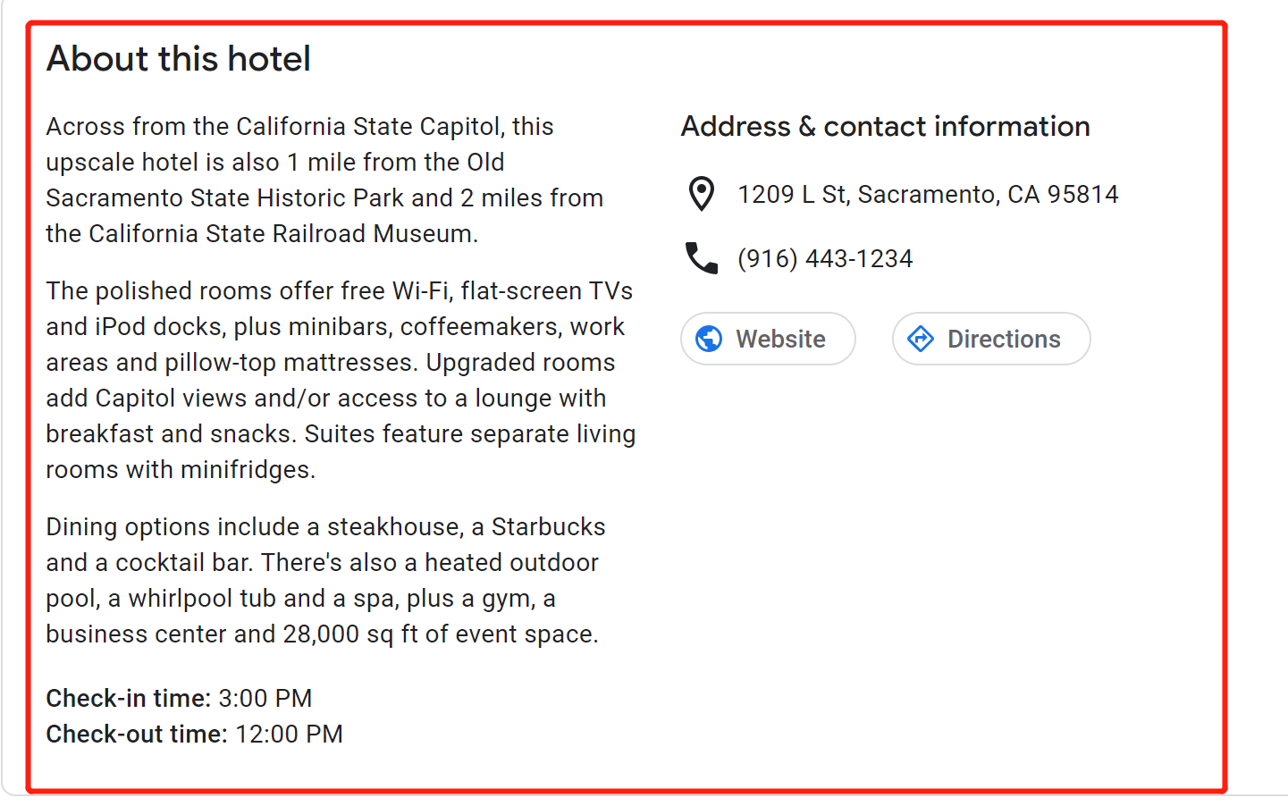

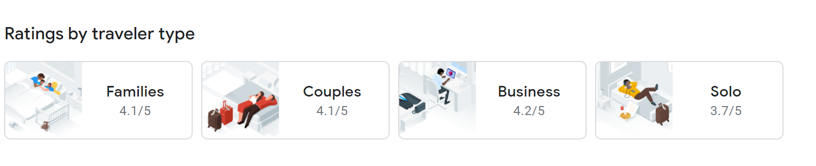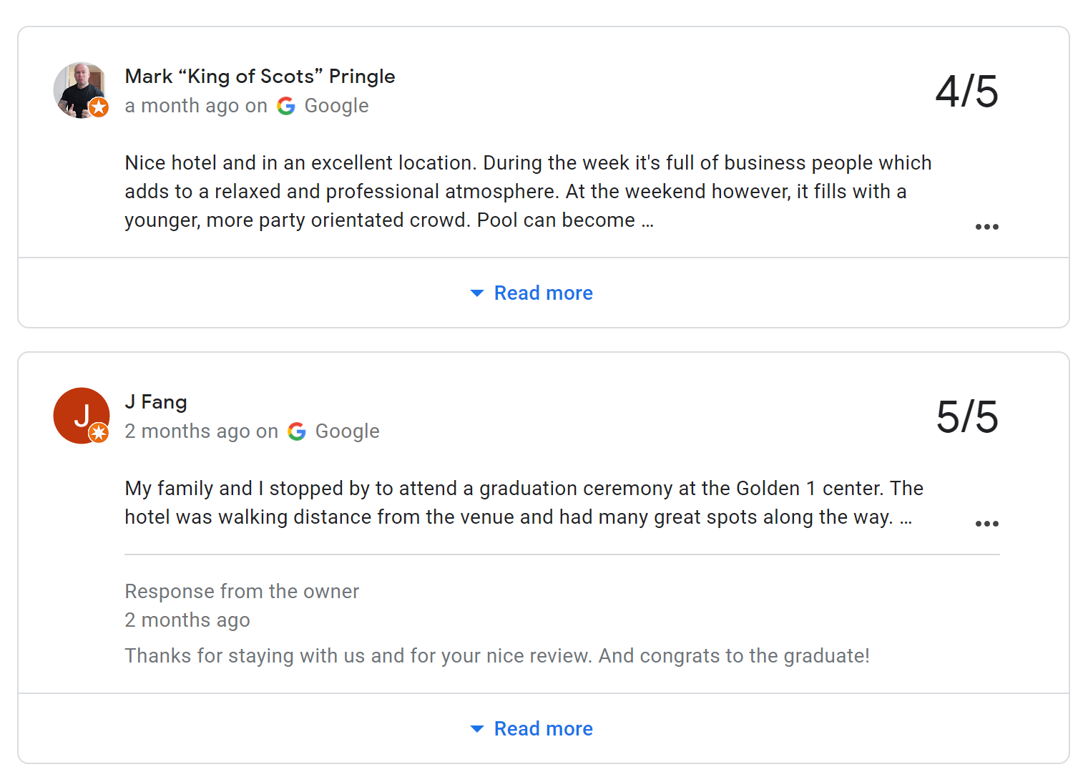

1. In the way, we can collect the data of, for example. 20 or 30 hotels, and make it looks like the target site I sent

<https://hotels-with-balcony.com/san-francisco/>